

Project Phase 1

Team Name: AutoPed  
Team Number: 40  
Members: Vihaan Patel, Naman Gandhi, Ayush Shejwal, Gautam Mehta, Swar Khatav

# Project Overview

The overview of the project will break down the application into its required elements. This will include access portals for the patients, nurses, and doctors, and a brief walkthrough of the application functionality and how all elements connect to each other.

## Login Page

This page will be for patients to either create or sign in to an existing account.  
Page elements incorporating the requirements:

1. Application logo
2. Login/account instructions
3. Text entry fields: First name, Last name, Date of birth
4. Sign up/Sign in button

On entering the required information, the user can proceed with logging into the application. The application will create an account if the given information does not match an existing account. If the information does match, the application will login into the existing account and fetch the corresponding data.

Proceeding with login will navigate the user to the patient portal of the application.

## Patient’s Portal

This page will be the primary interface for patients, letting them change their contact information, view previous visits, and directly message doctors and nurses.  
Page elements incorporating the requirements:

1. Application logo
2. Section 1: Account and contact details
   1. Account information: Name and date of birth
   2. Contact information: Phone number/email
3. Section 2: Visit History
   1. Previous visits marked by date
   2. Record of prescriptions tied to each visit (visit summary)
4. Section 3: Patient information
   1. Vitals: weight, height, body temperature, blood pressure (to be updated by nurse on visit)
   2. History: Known allergies, previous immunizations, medications, health concerns
5. Section 4: Messaging  
   Texting interface between patient, doctor, and nurse and option for urgent contact.

## Nurse’s Portal

The nurse’s portal will have access to all patients with an account in the application. The user can enter the information of any patient and view their details and update their vitals on visit.   
Page elements incorporating the requirements:

1. Application logo
2. Section 1: Enter patient details (name and date of birth) to retrieve specific information tied to the patient’s account.
3. Section 2: Retrieved information
   1. Body vitals
   2. Known allergies, Health issues
   3. Prescribed medication and immunization history
4. Section 3: Messaging  
   Texting interface for nurses, can view messages from all patients when in general view, and when patient selected, can view that patient’s messages.

The nurse can update patient information as required on a visit.

## Doctor’s Portal

Doctor’s portal will have the same layout as the nurse’s portal, with the added feature of editing the prescriptions. Users can add a new entry into the visit field and attach a new prescription into the patient record.

# User Interface Walkthrough

GUI Walkthrough

Human Interface Design:

The user interface design consists of 4 different pages. The login page, Patient’s portal, Nurse’s portal, and doctor’s portal. These 4 entirely encapsulate the functionality of the Autoped.

## Login Page

The login page has simple functionality: The person must enter details. If the account exists, the member is taken to the respective portal, if not, a new account is created.

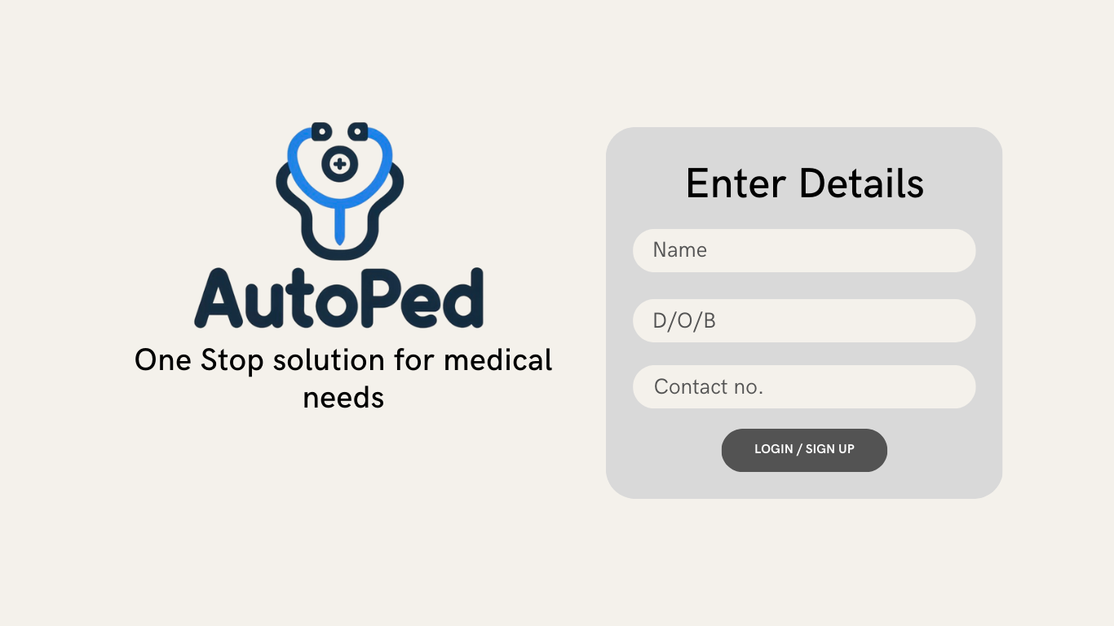

## Patient’s portal

The patient’s portal consists of several features- Contact info (Personal and account details), Visit history (Recent visits and all the notes attached with the visit), Medical info (Updated medical info including all the medication and allergic history). A special messaging feature that connects patients, nurses, and doctors.

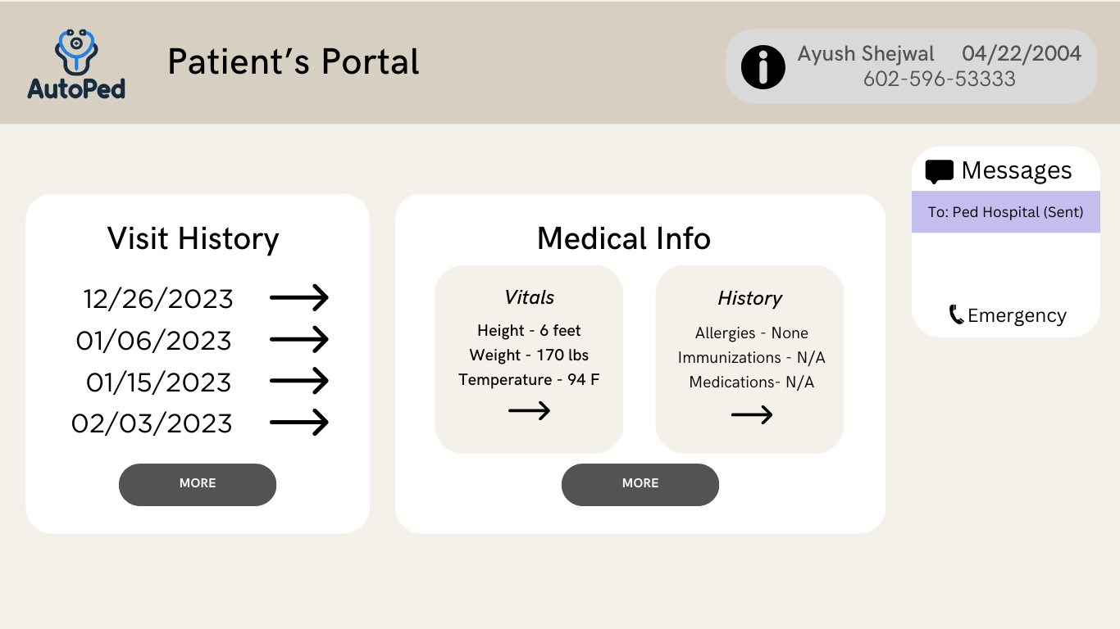

## Nurse’s portal

The nurse’s portal consists of the following functionalities-

1. Search bar- Searches Patients
2. Info bar- Shows all the information related to the patient
3. Contact info (Personal and account details)
4. Messaging feature

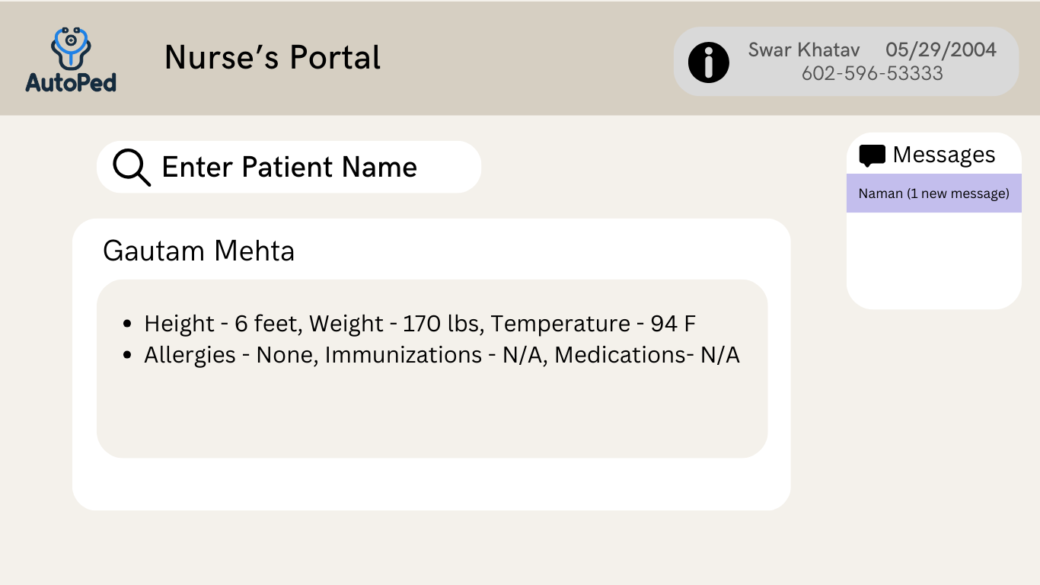

## Doctor’s portal

The doctor’s portal consists of the following functionalities-

1. Search bar- Searches Patients
2. Info bar- Shows all the information related to the patient
3. Contact info (Personal and account details)
4. Messaging feature
5. Add prescription button (Allows doctors to add notes, prescriptions required for the patient)

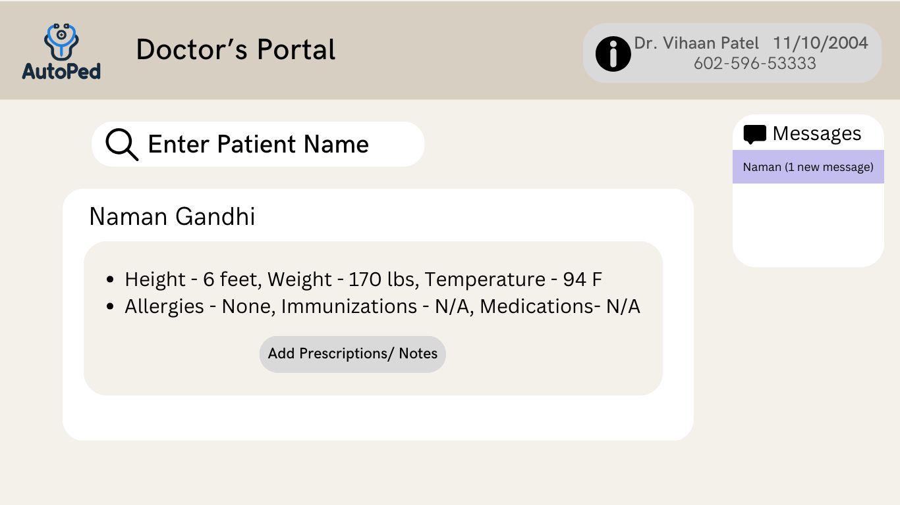

# Credit Sheet – Team 40

|  |  |  |  |
| --- | --- | --- | --- |
| **Member Name** | **Cover Page** | **Project Overview** | **UI Walkthrough** |
| Vihaan Patel | 20% | 20% | 20% |
| Naman Gandhi | 20% | 20% | 20% |
| Ayush Shejwal | 20% | 20% | 20% |
| Gautam Mehta | 20% | 20% | 20% |
| Swar Khatav | 20% | 20% | 20% |